











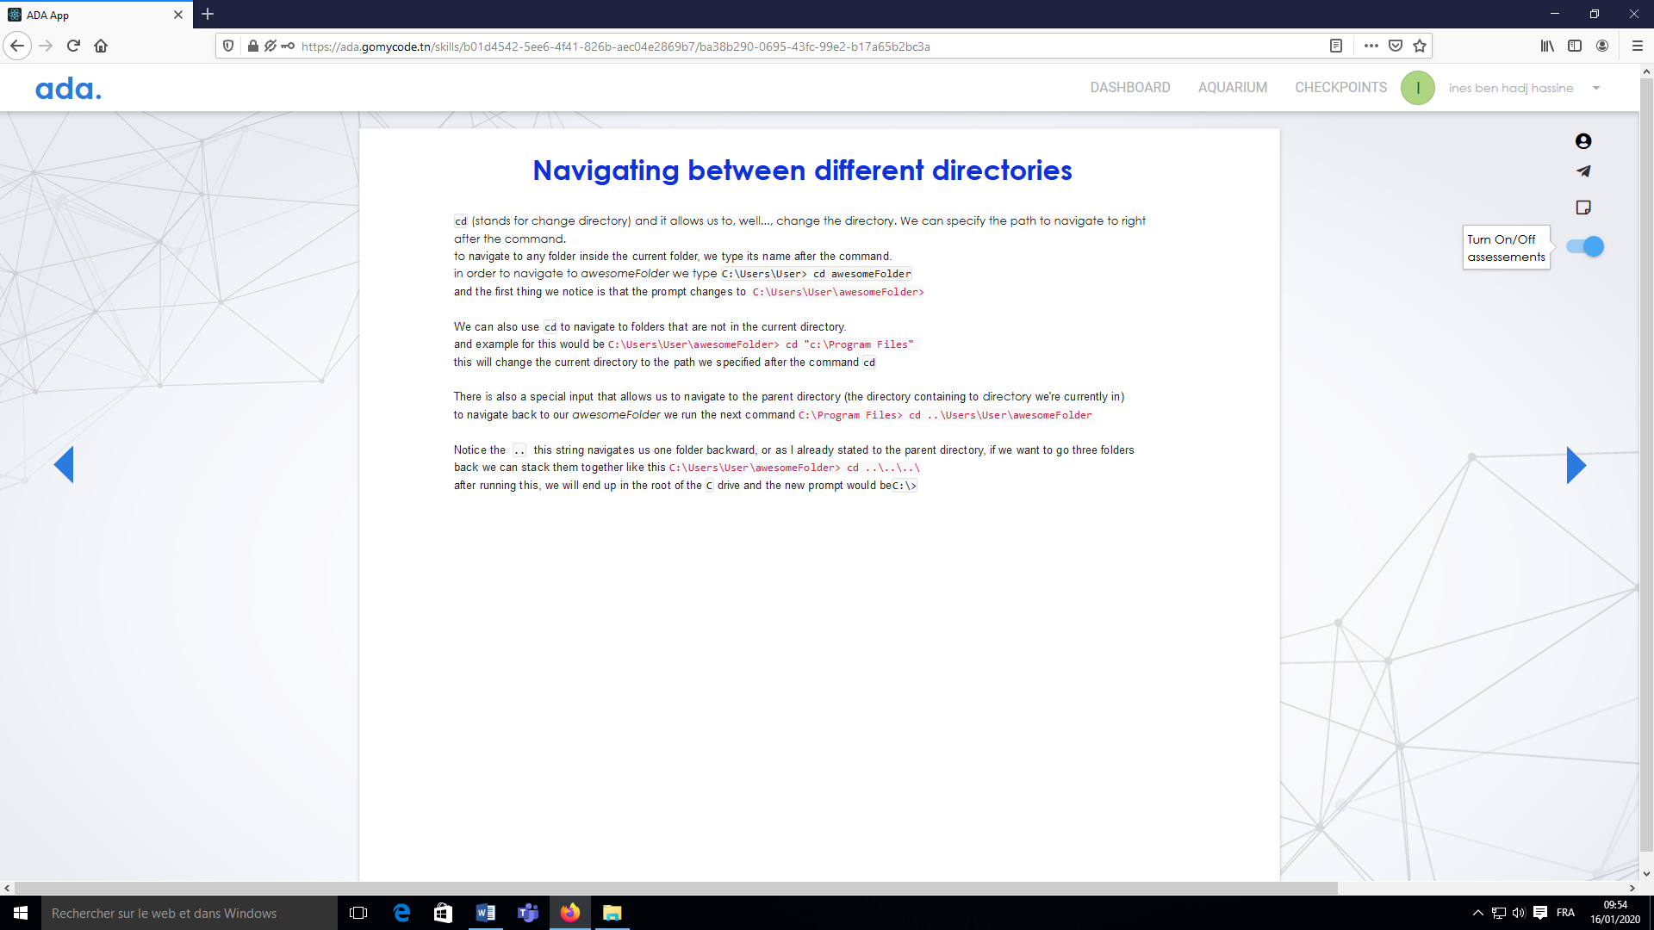













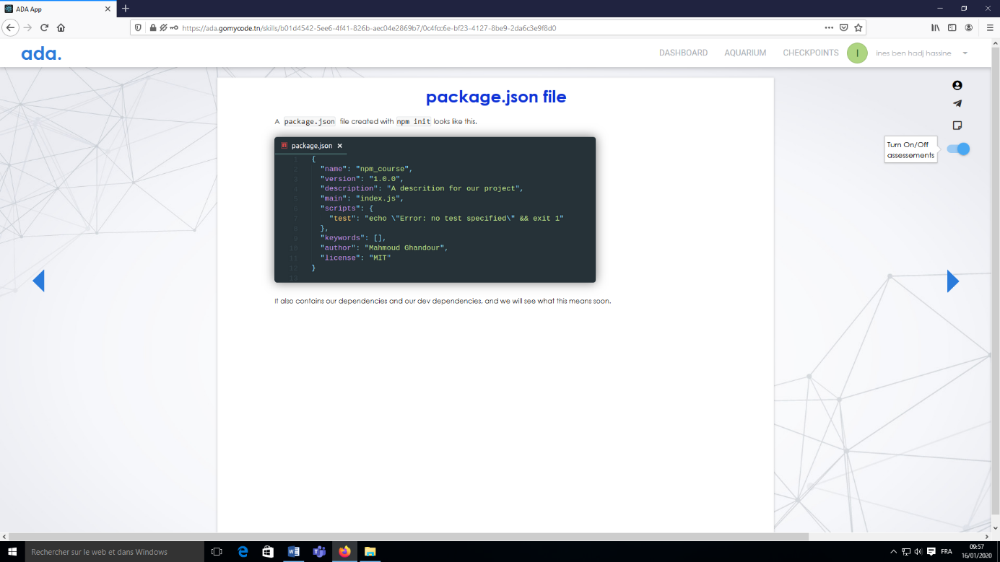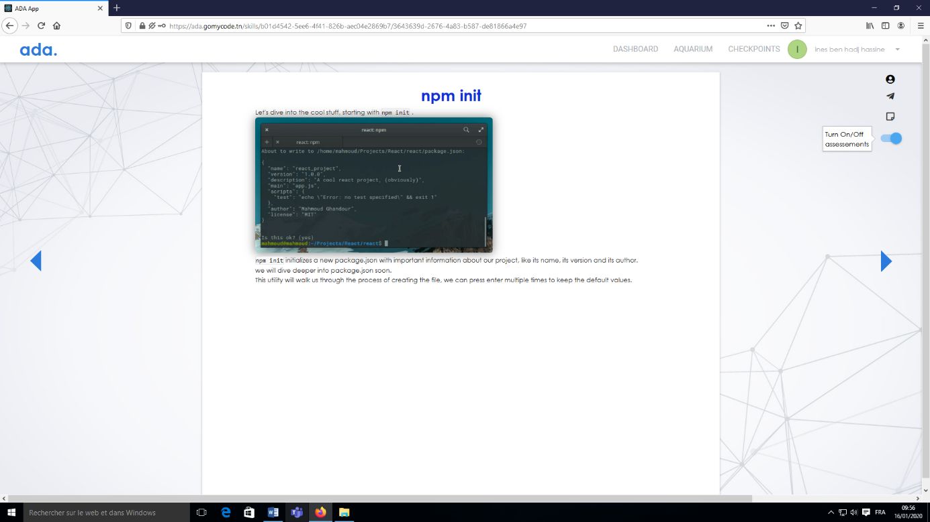



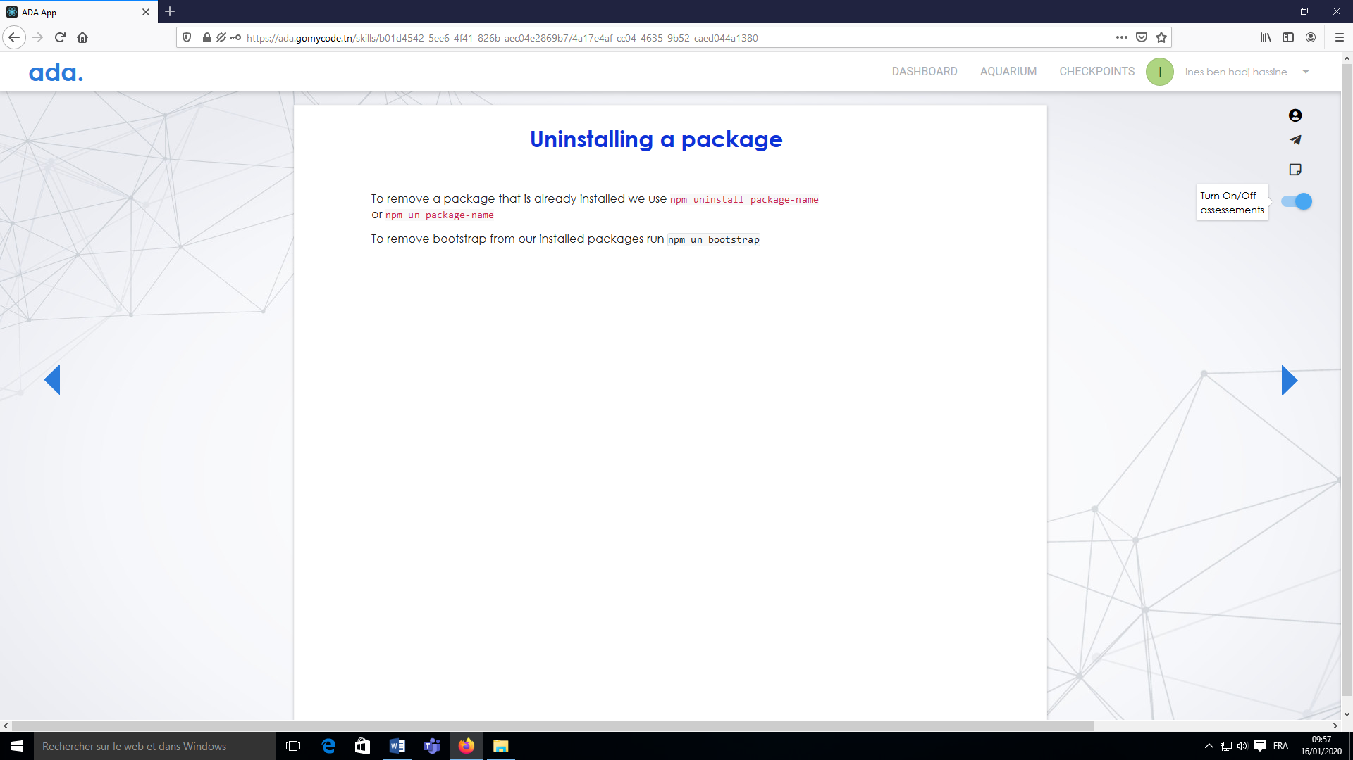







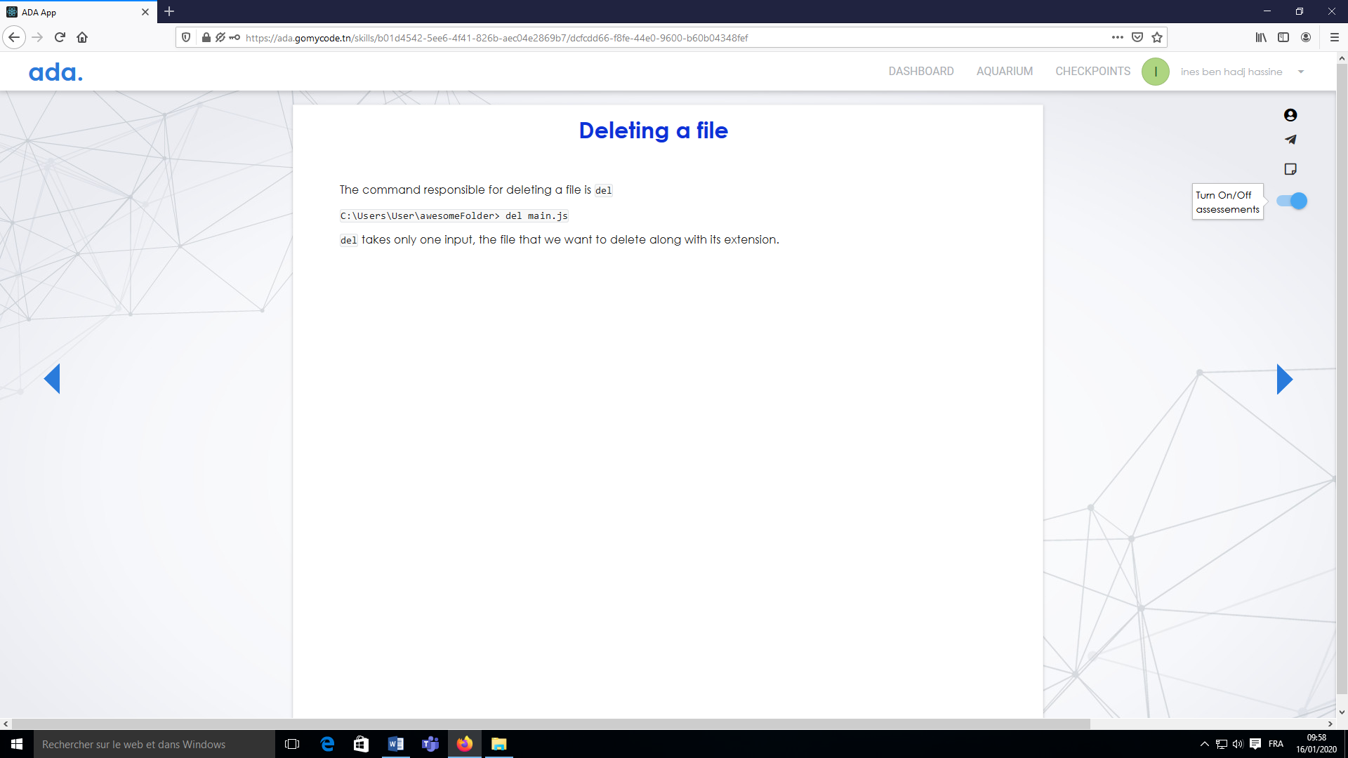

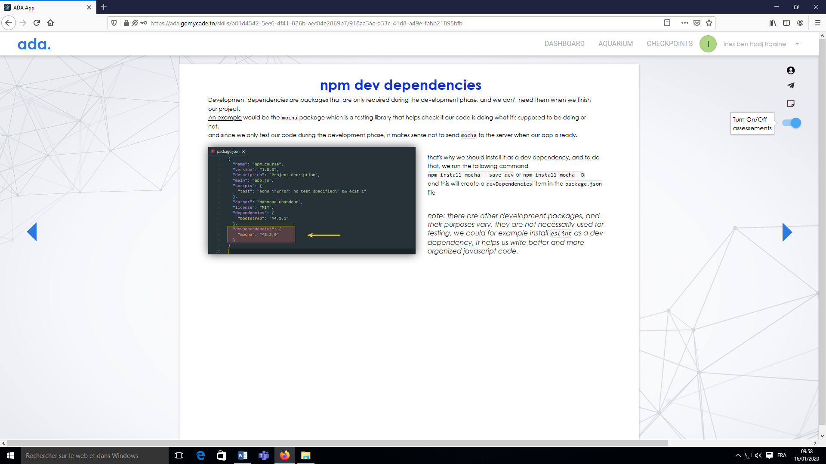







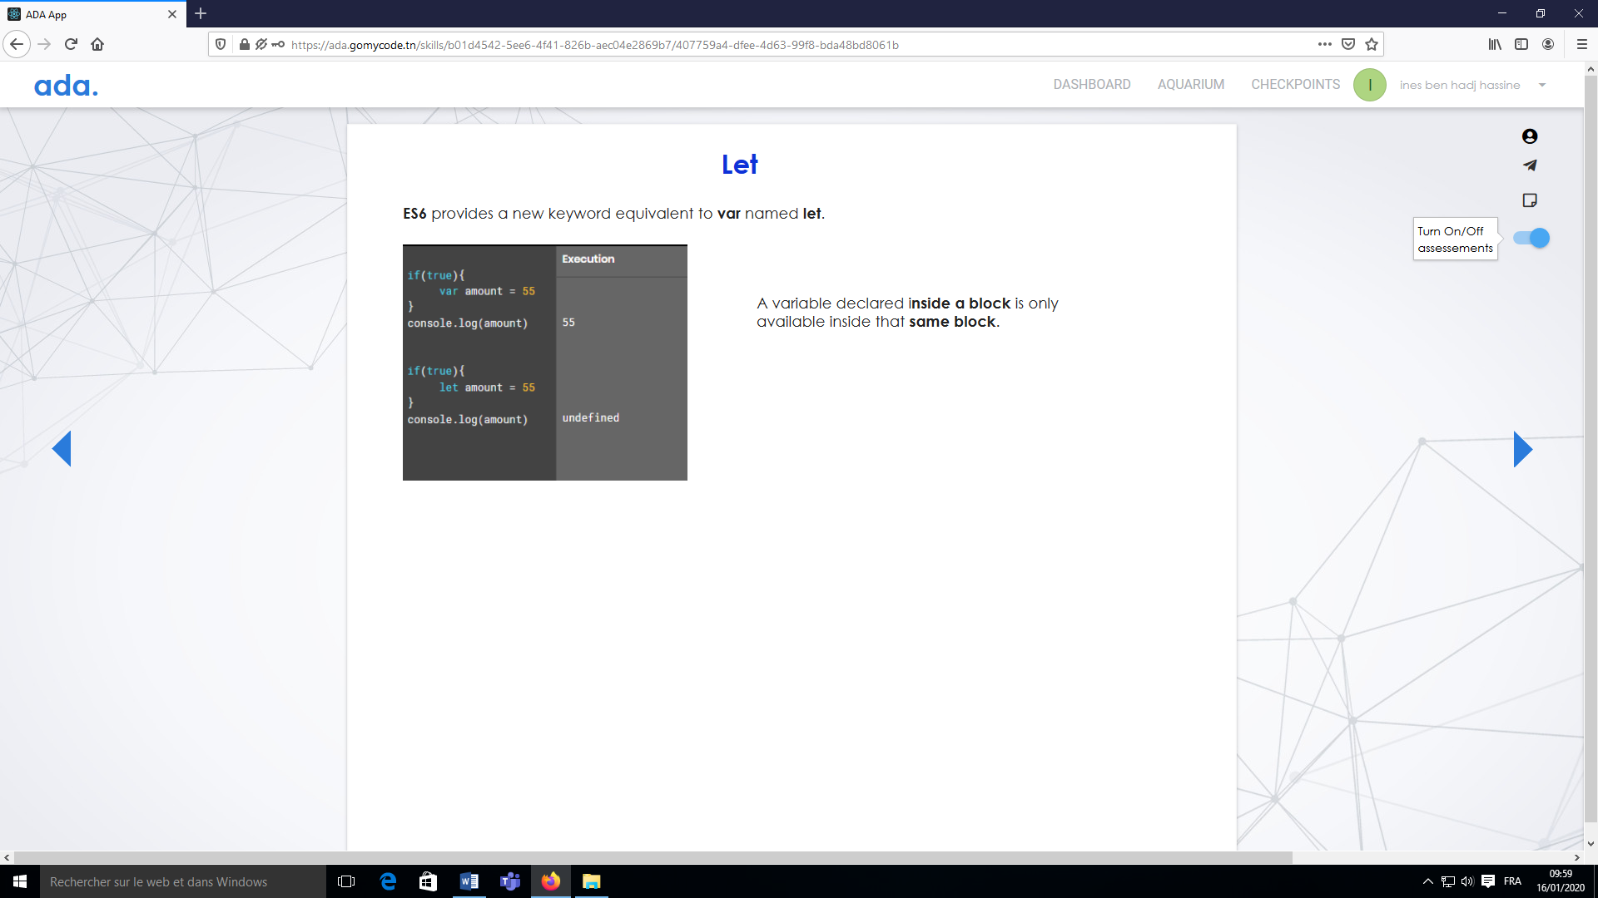



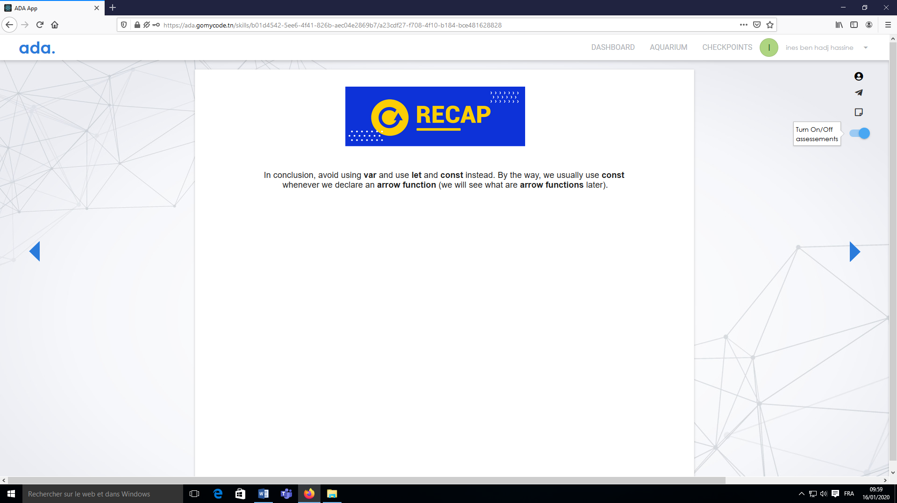

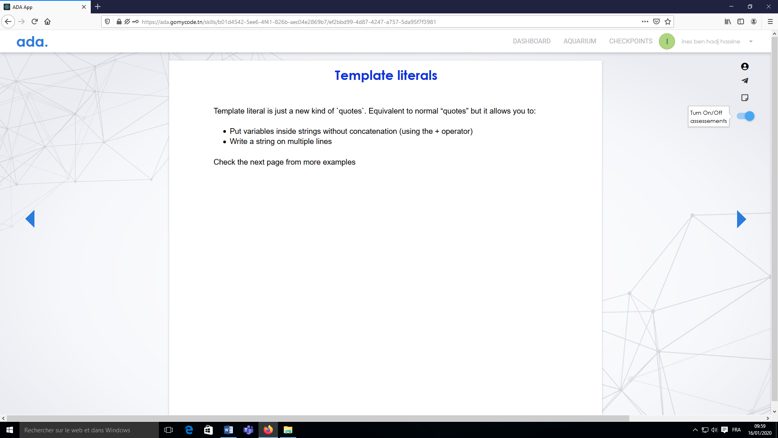

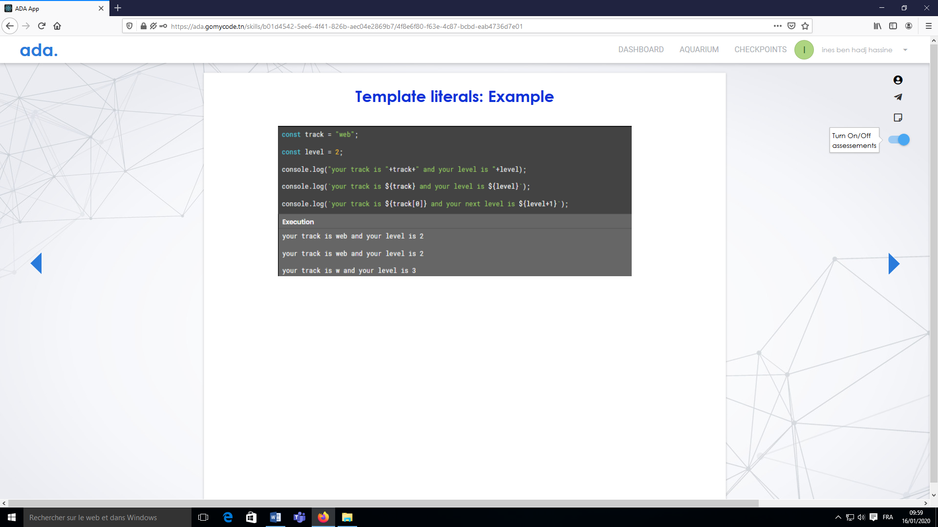

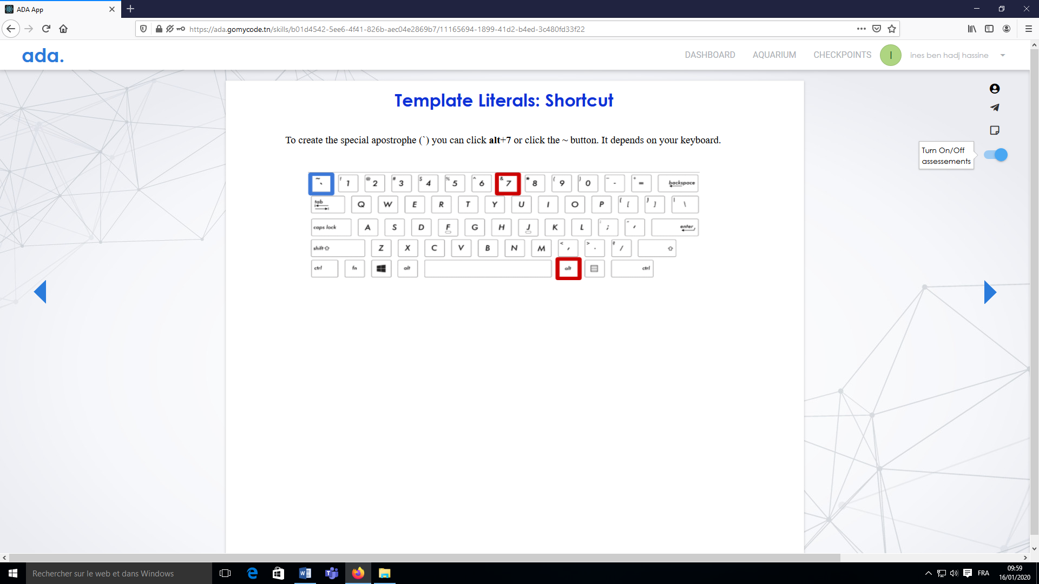

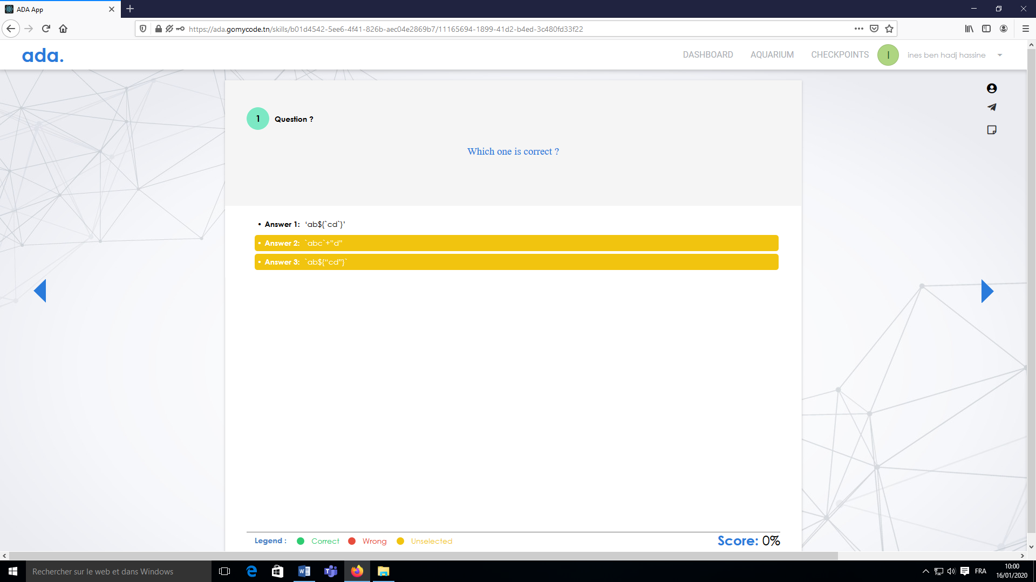

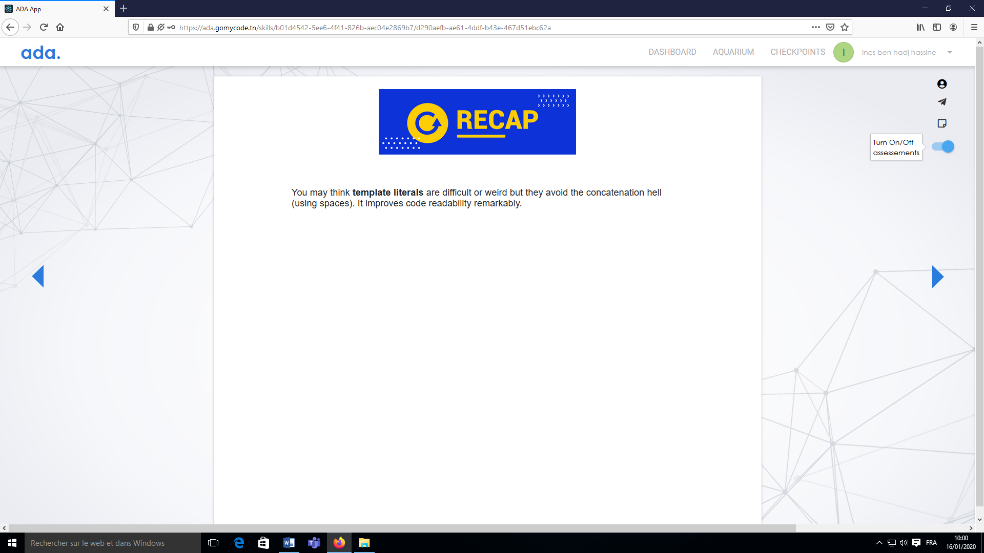

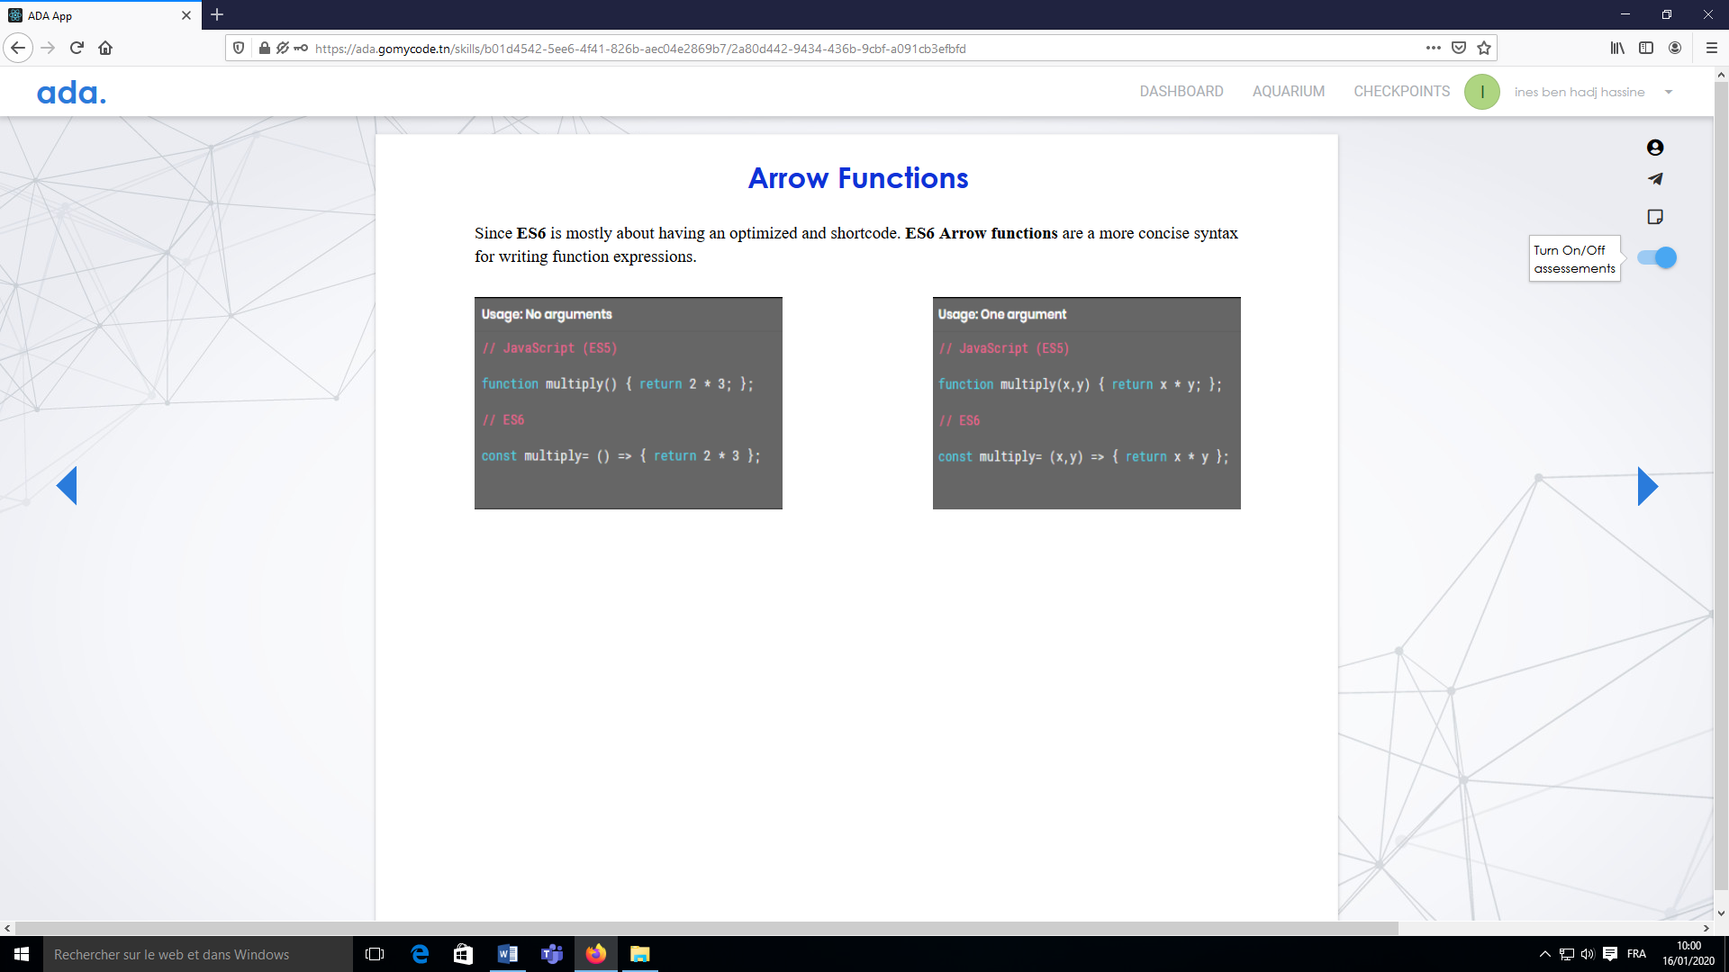

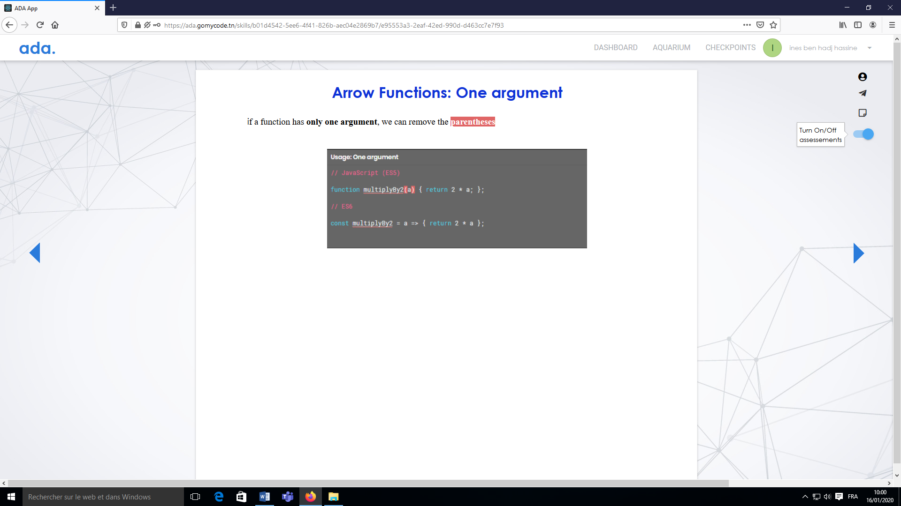

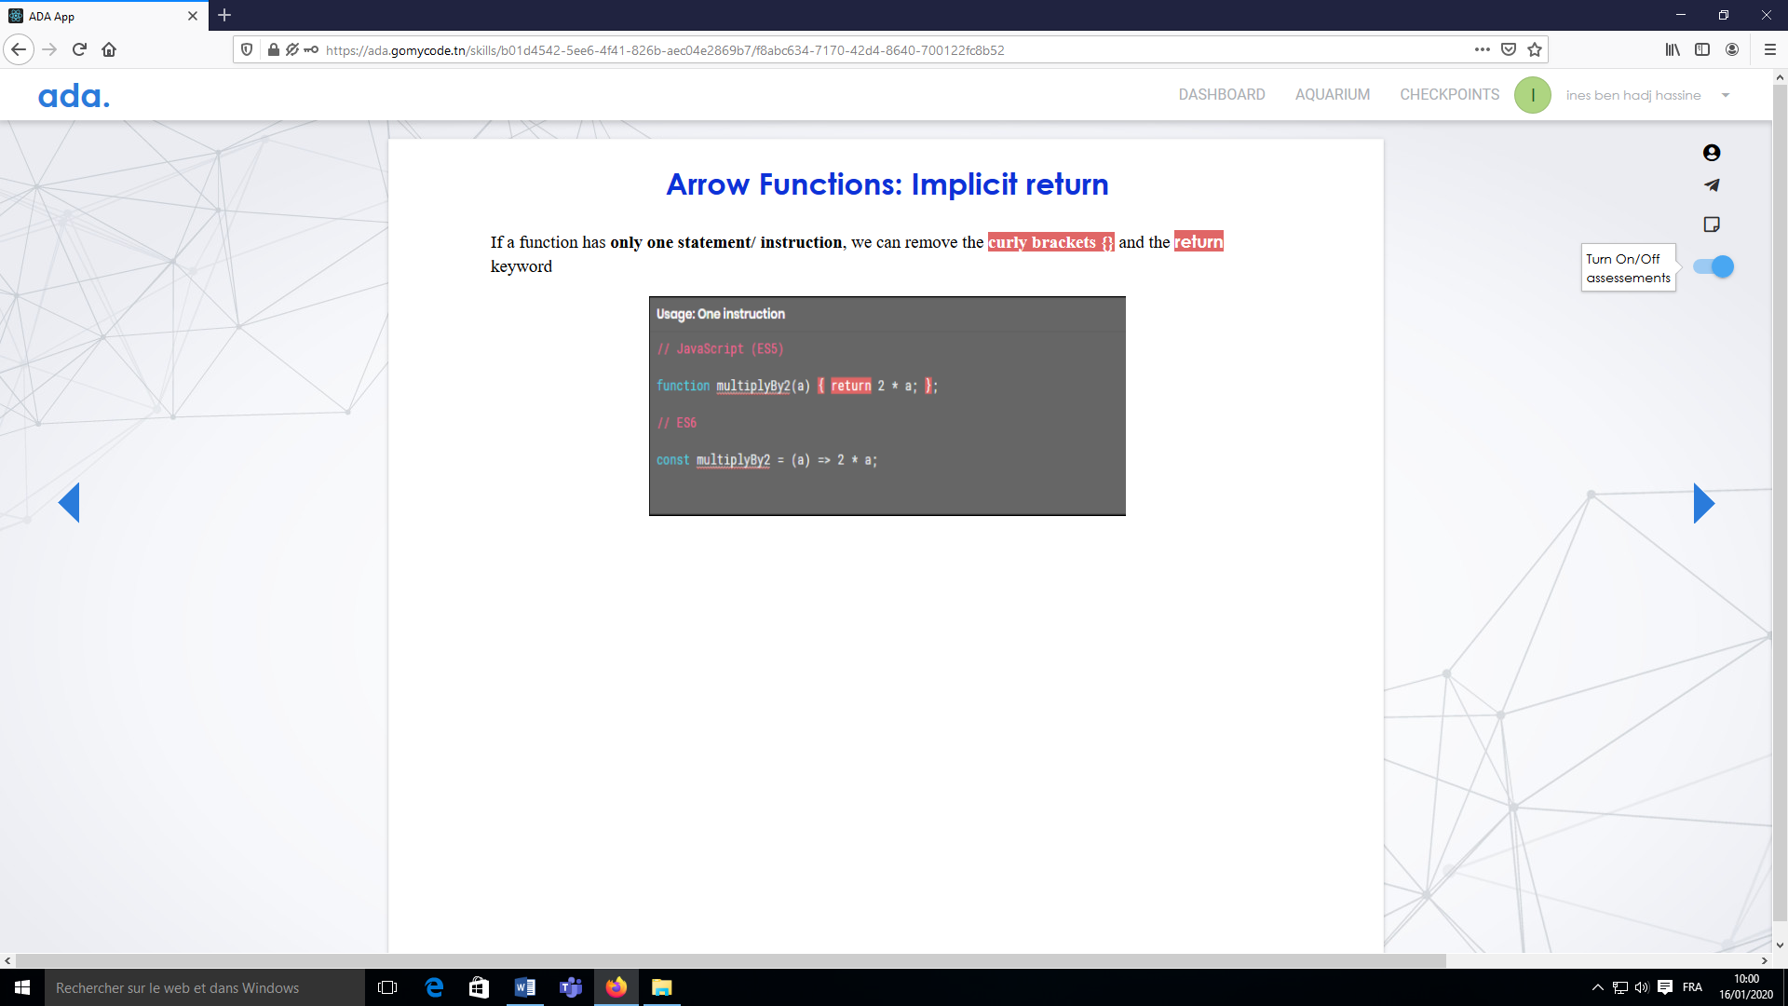

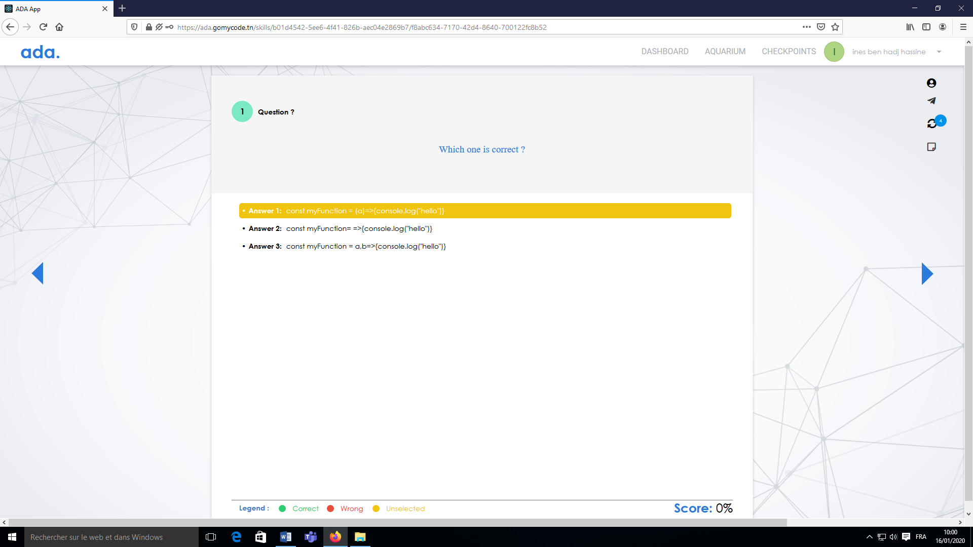

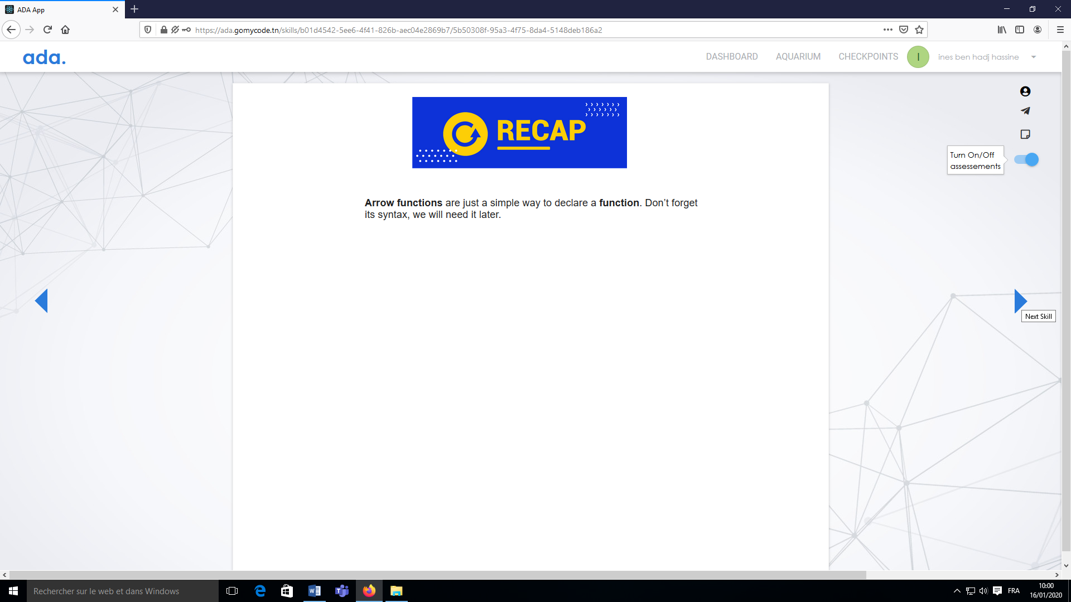



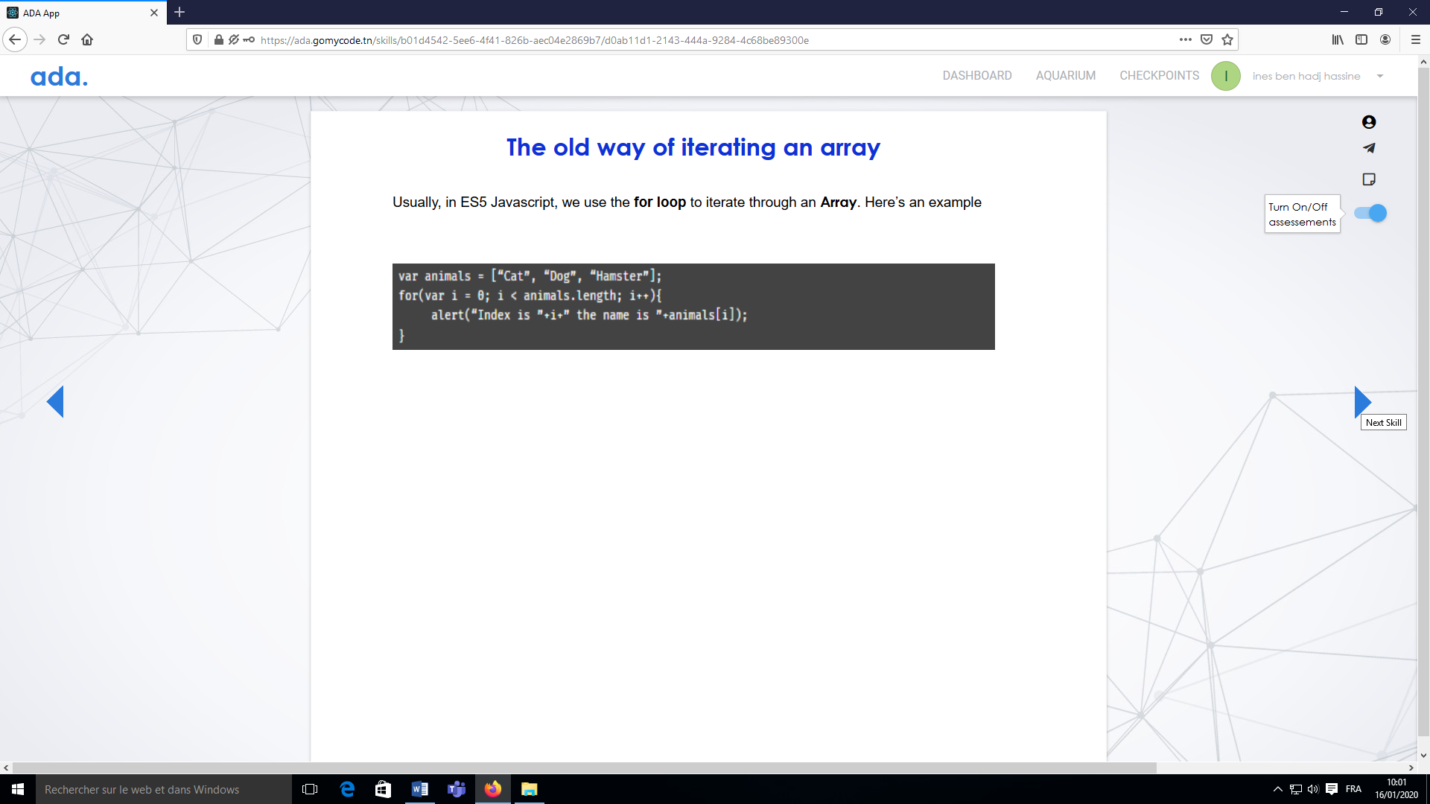



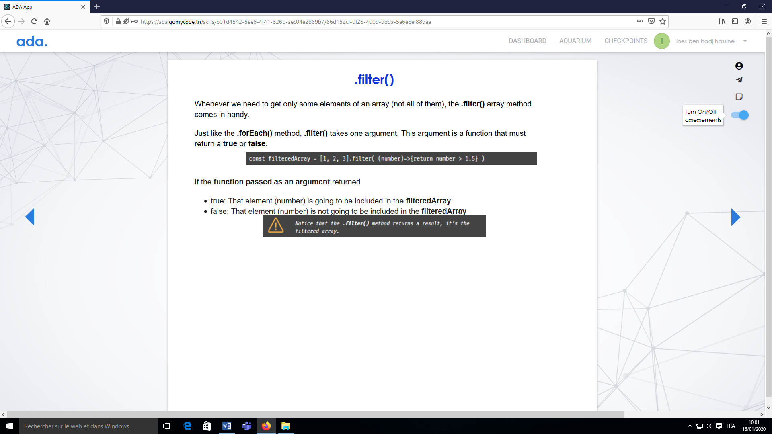

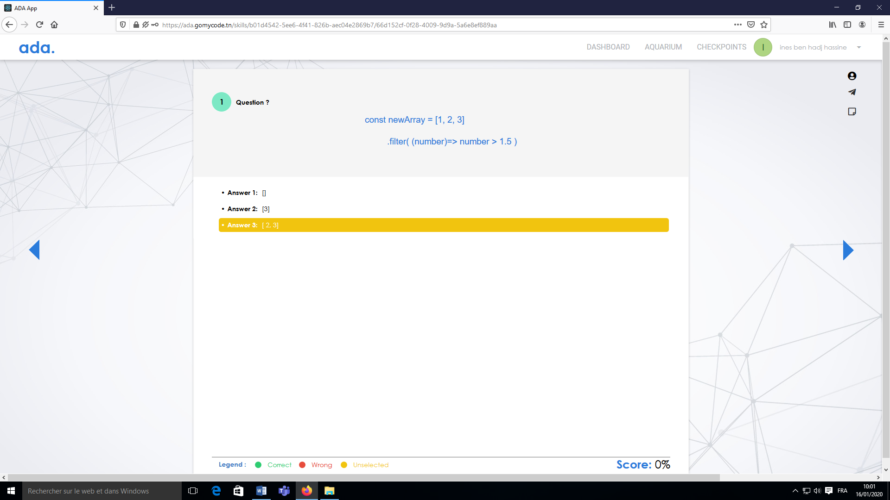

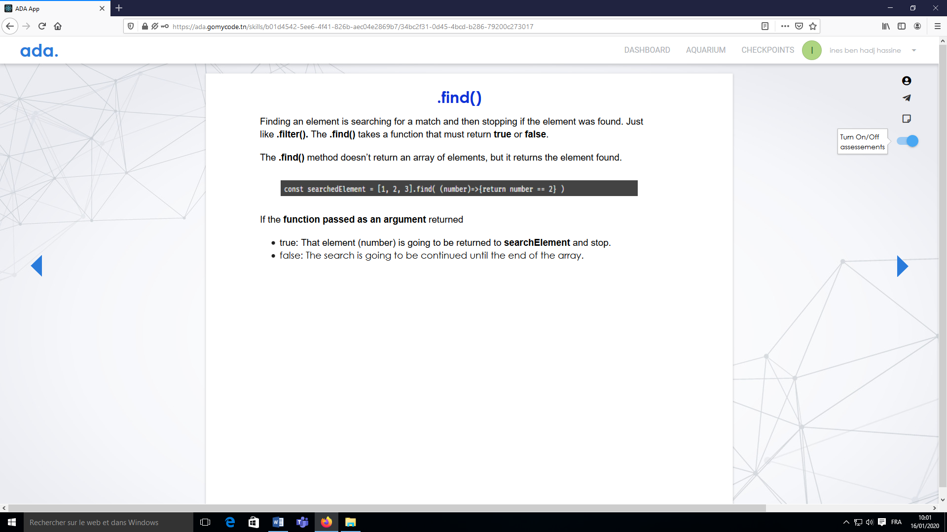

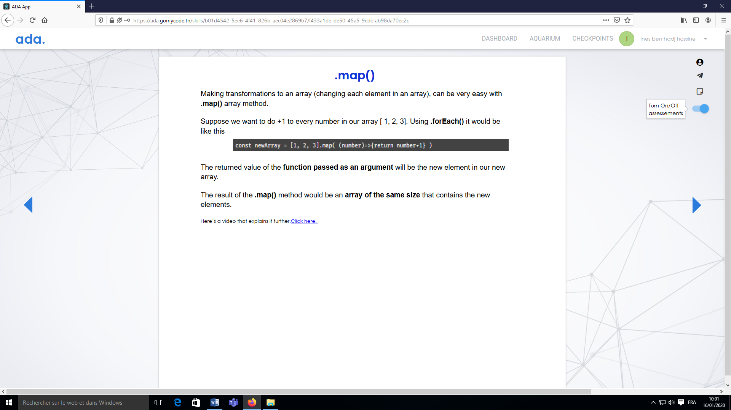

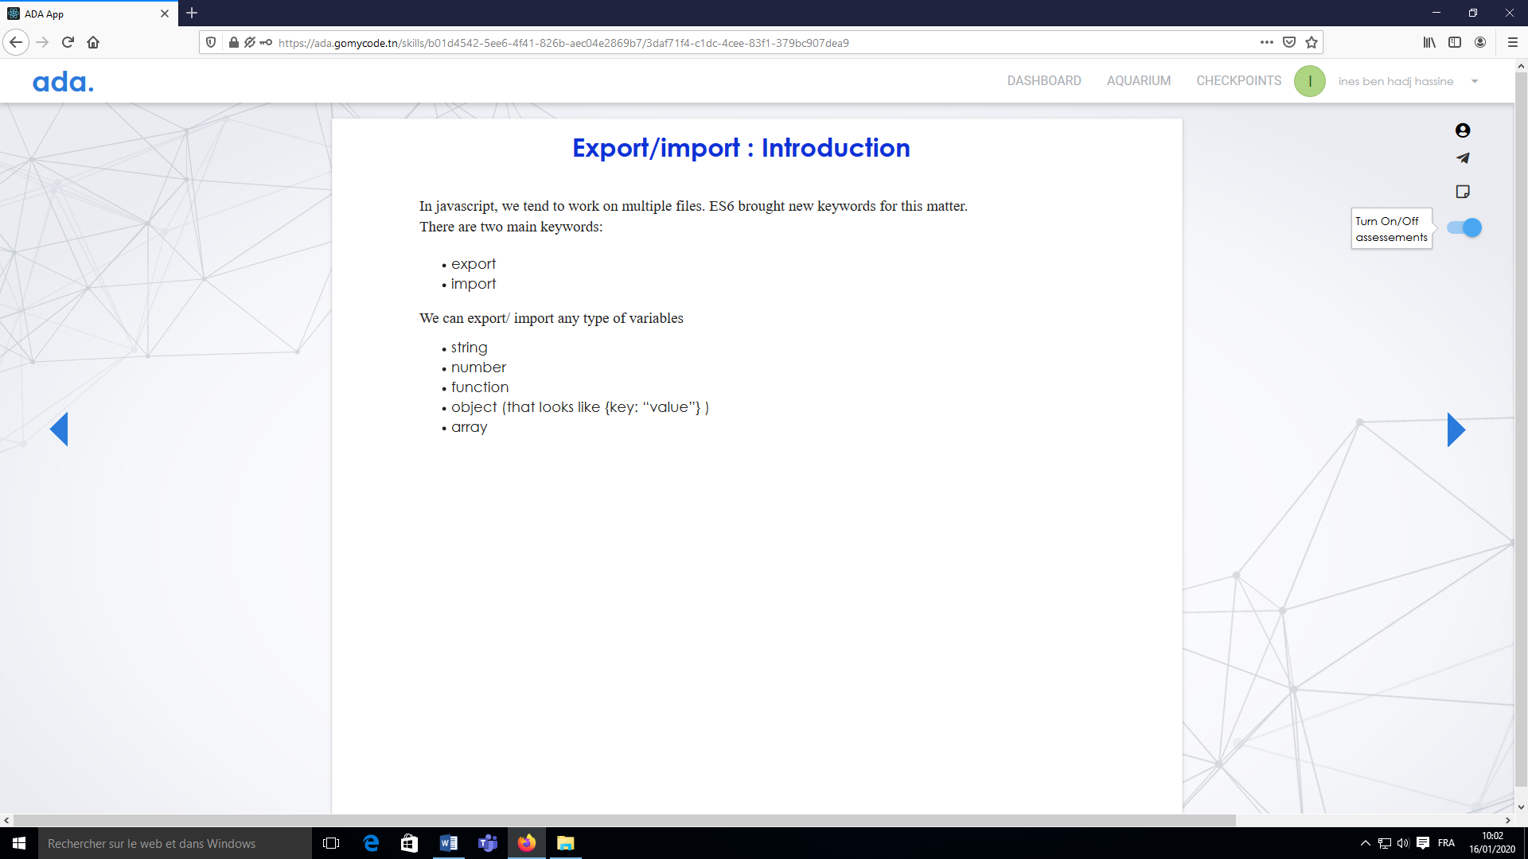

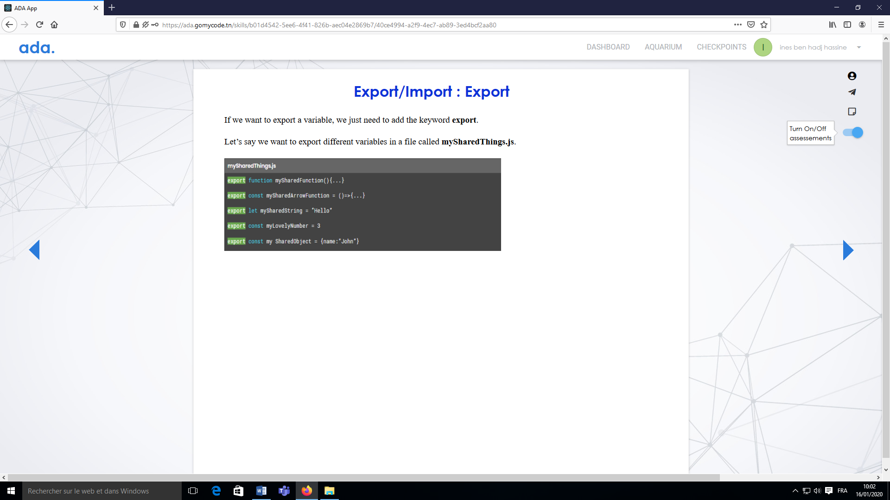

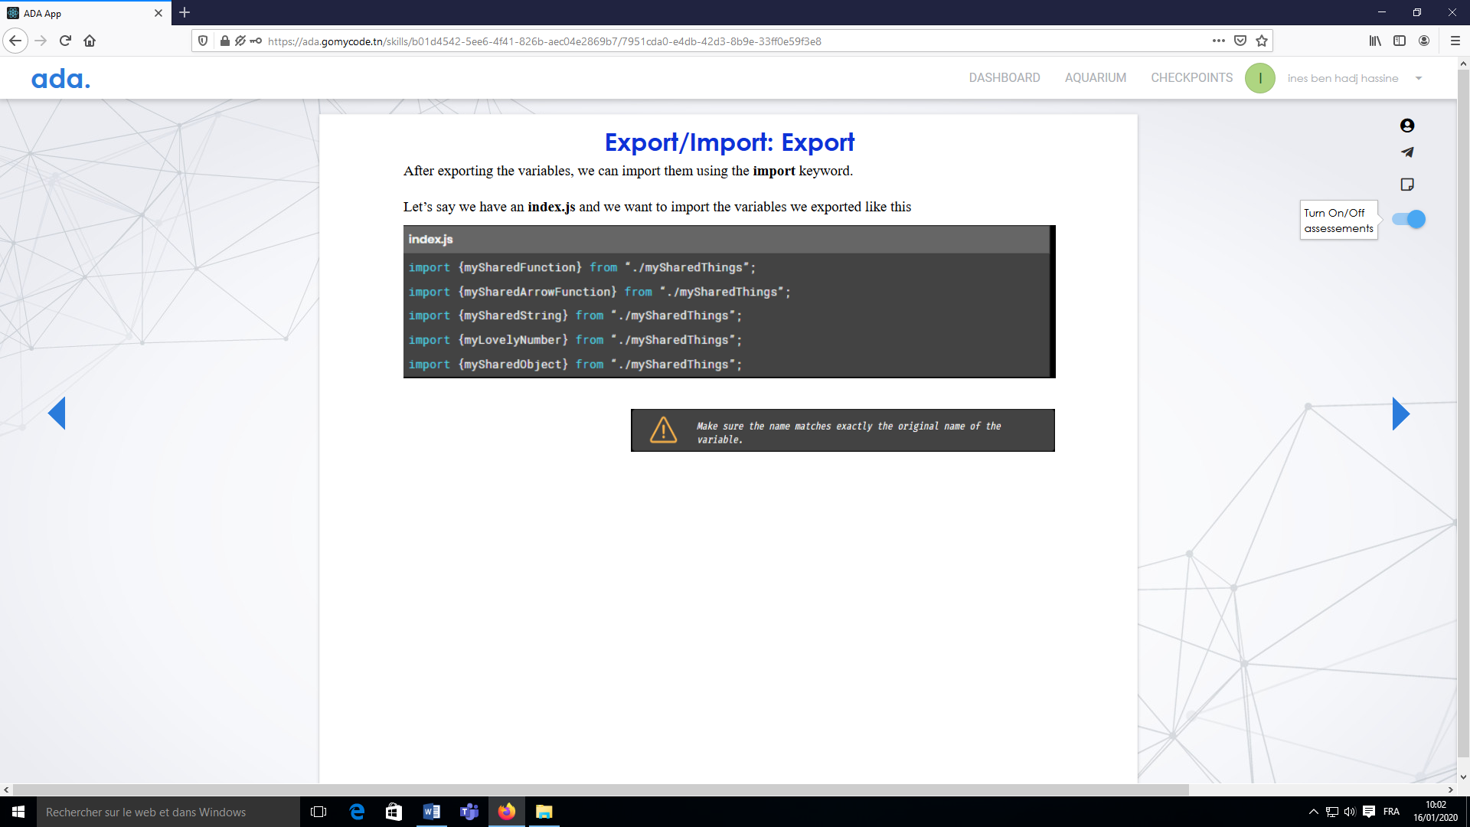

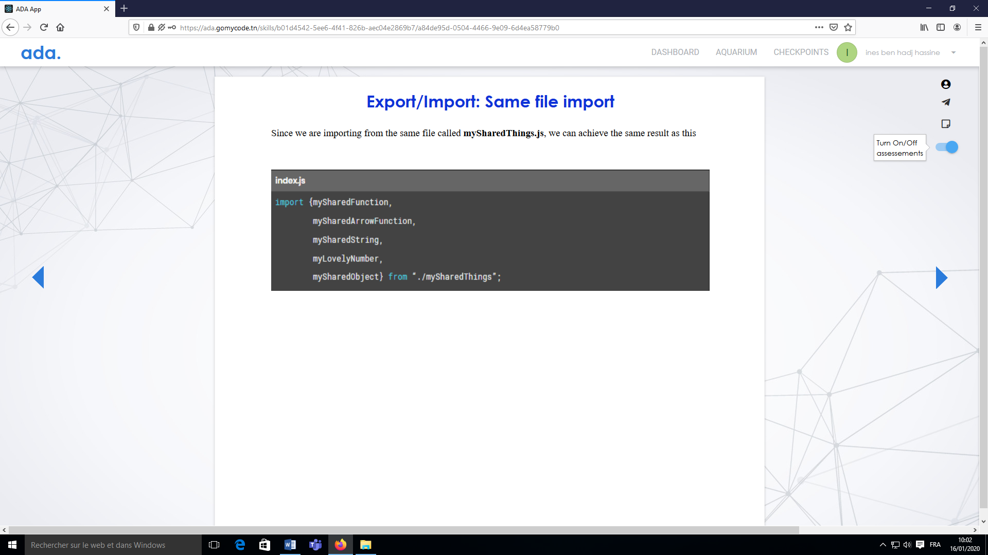



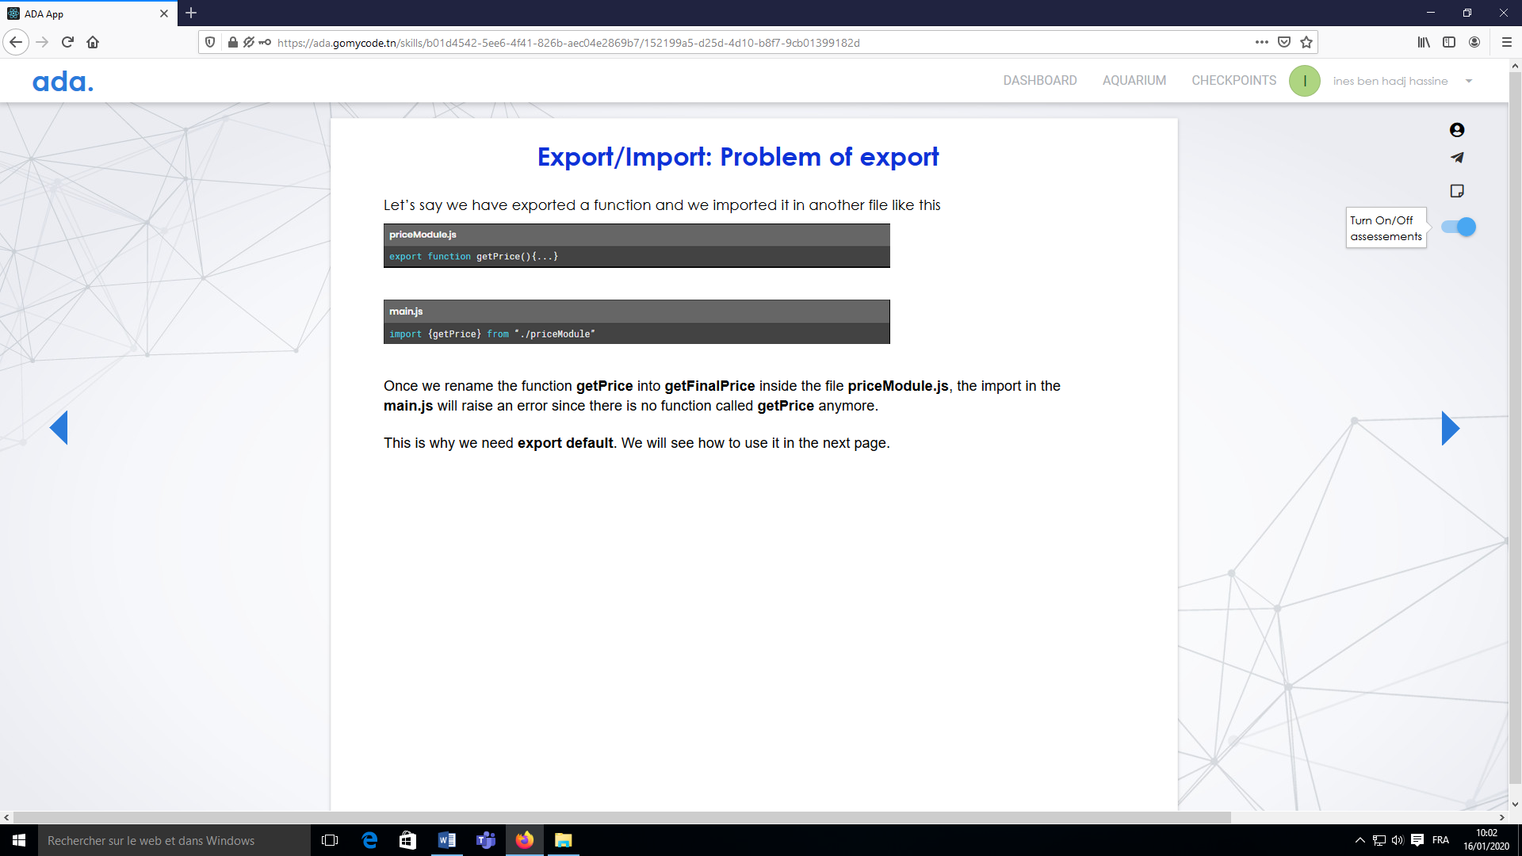



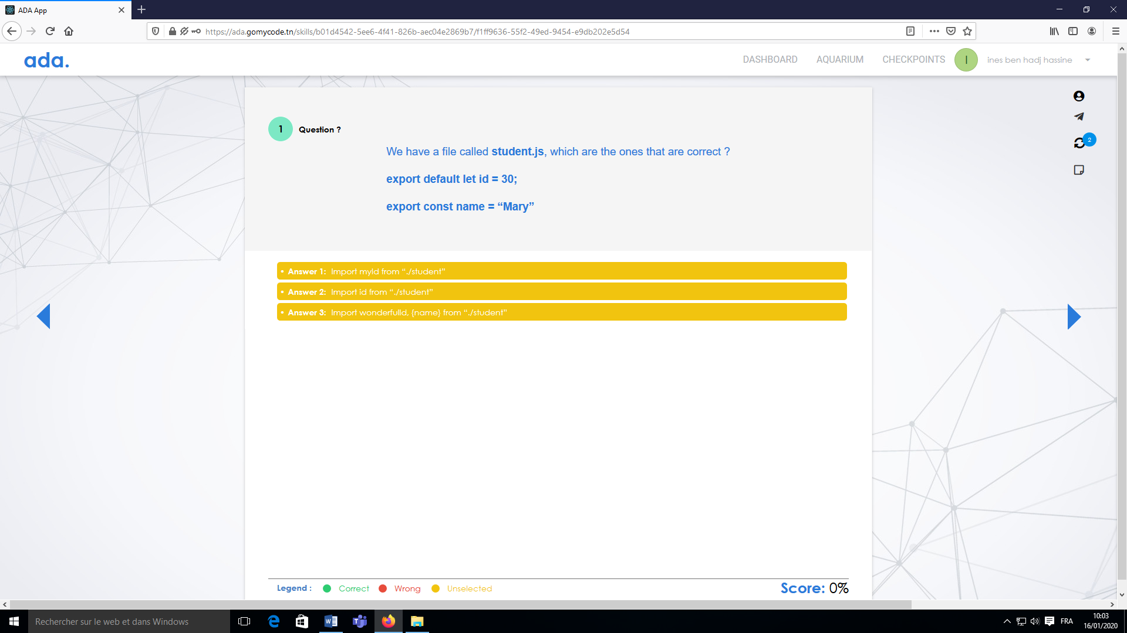

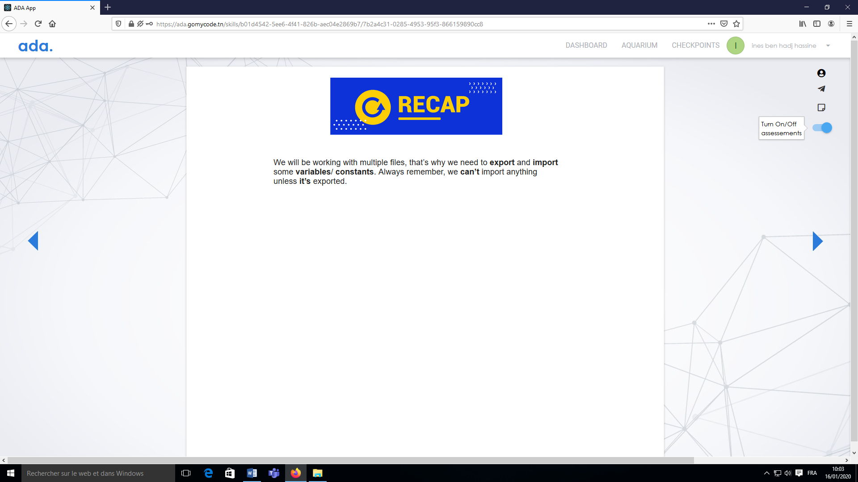



|  |
| --- |
| var pets = [ |
|  |

|  |
| --- |
| { name: "Max", type: "dog", bornOn: 2018 }, |
|  |

|  |
| --- |
| { name: "Angel", type: "cat", bornOn: 2015 }, |
|  |

|  |
| --- |
| { name: "Jasper", type: "dog", bornOn: 2016 } |
|  |

|  |
| --- |
| ]; |
|  |

|  |
| --- |
|  |
|  |

|  |
| --- |
| function getAge(pet) { |
|  |

|  |
| --- |
| return new Date().getFullYear() - pet.bornOn; |
|  |

|  |
| --- |
| } |
|  |

|  |
| --- |
|  |
|  |

|  |
| --- |
| var petsWithAge = []; |
|  |

|  |
| --- |
| for (var i = 0; i < pets.length; i++) { |
|  |

|  |
| --- |
| var pet = pets[i]; |
|  |

|  |
| --- |
| pet.age = getAge(pet); |
|  |

|  |
| --- |
|  |
|  |

|  |
| --- |
| petsWithAge.push(pet); |
|  |

|  |
| --- |
| } |
|  |

|  |
| --- |
| console.log(petsWithAge); |
|  |

|  |
| --- |
|  |
|  |

|  |
| --- |
| var dogs = []; |
|  |

|  |
| --- |
| for (var i = 0; i < pets.length; i++) { |
|  |

|  |
| --- |
| var pet = pets[i]; |
|  |

|  |
| --- |
| if (pet.type === "dog") { |
|  |

|  |
| --- |
| dogs.push(pet); |
|  |

|  |
| --- |
| } |
|  |

|  |
| --- |
| } |
|  |

|  |
| --- |
| console.log(dogs); |
|  |

|  |
| --- |
|  |
|  |

|  |
| --- |
| var jasper; |
|  |

|  |
| --- |
| for (var i = 0; i < pets.length; i++) { |
|  |

|  |
| --- |
| var pet = pets[i]; |
|  |

|  |
| --- |
| if (pet.name === "Jasper") { |
|  |

|  |
| --- |
| jasper = pet; |
|  |

|  |
| --- |
| } |
|  |

|  |
| --- |
| } |
|  |

console.log("Jasper is " + jasper.age + " years old");